Date:02.09.2021

**Third Year B. Tech., Sem V 2021-22**

**Programming Lab 3**

**Practical No- 3**

**PRN/ Roll No: 2019BTECS00064**

**Full name: Kunal Santosh Kadam**

**Batch: T2**

**Title of Practical: To Study web browser and its Development Tools option.**

**Problem Statement 1:**

Install different web browsers on your machine. Go through the Developer Tools option of the browser.

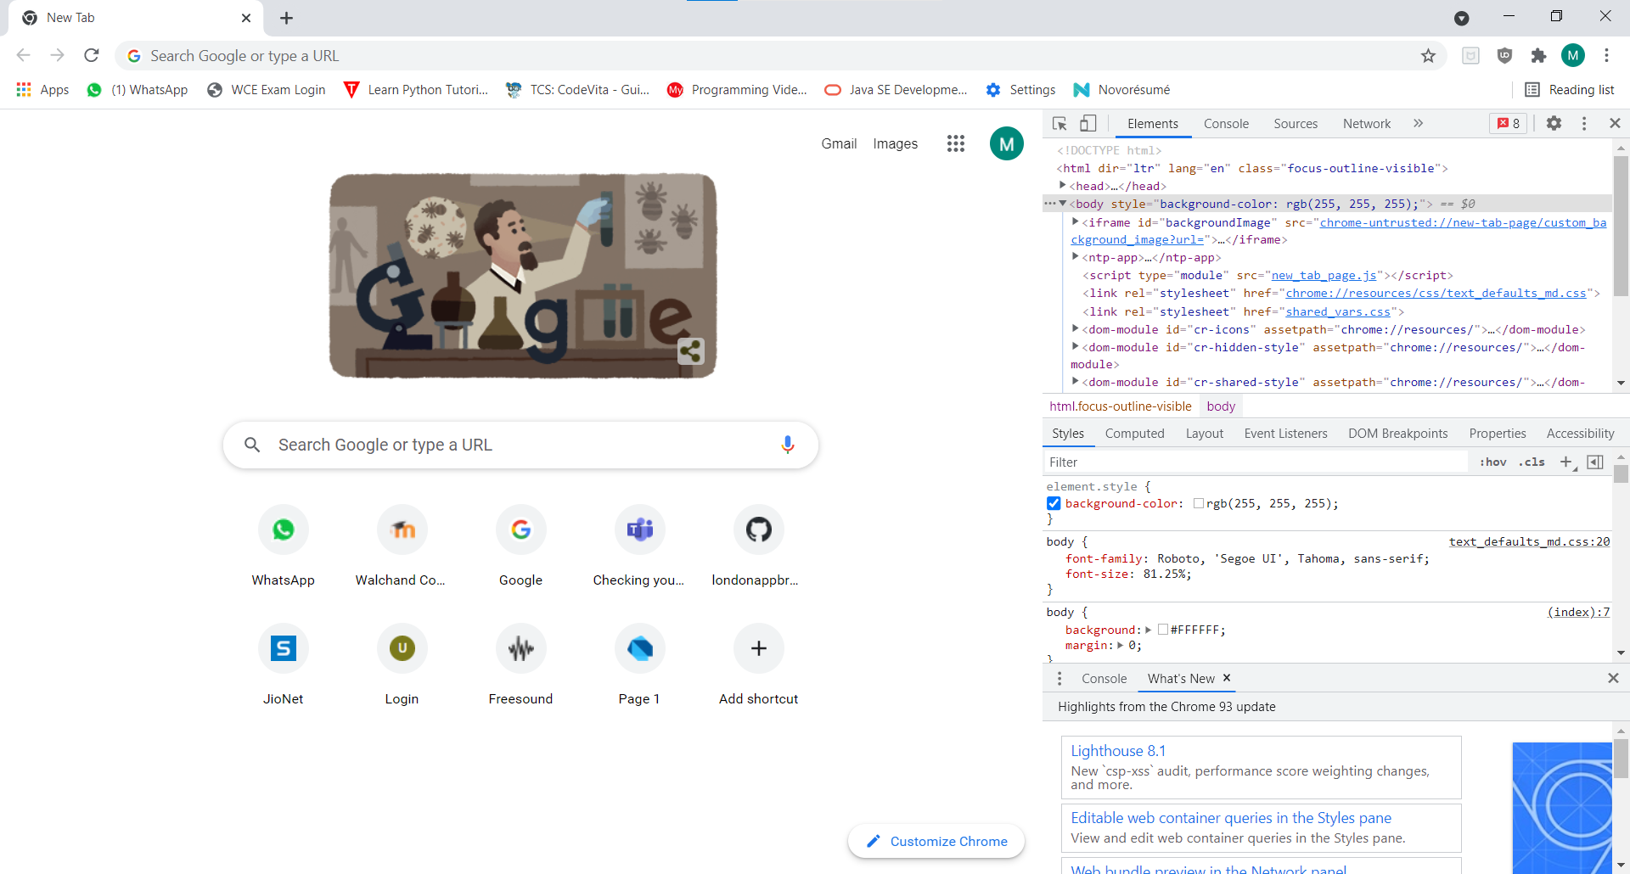

Developer Tool in Google Chrome

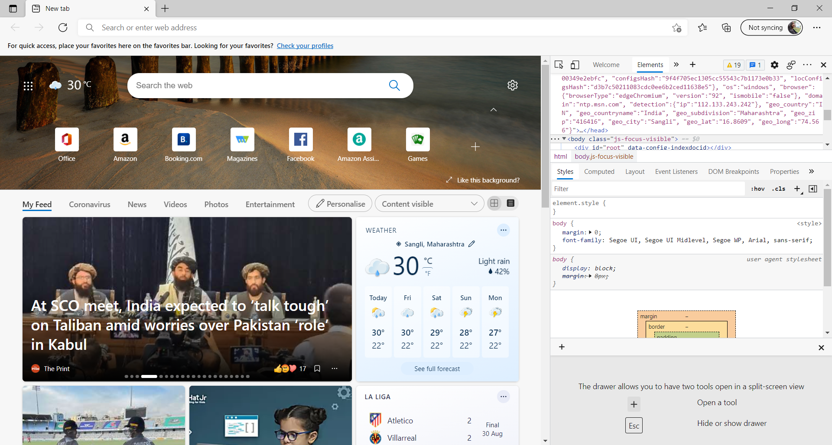

Developer Tool in Microsoft Edge

**Problem Statement 2:**

1. Visit <http://en.wikipedia.org/wiki/Computer_science> on various browsers.

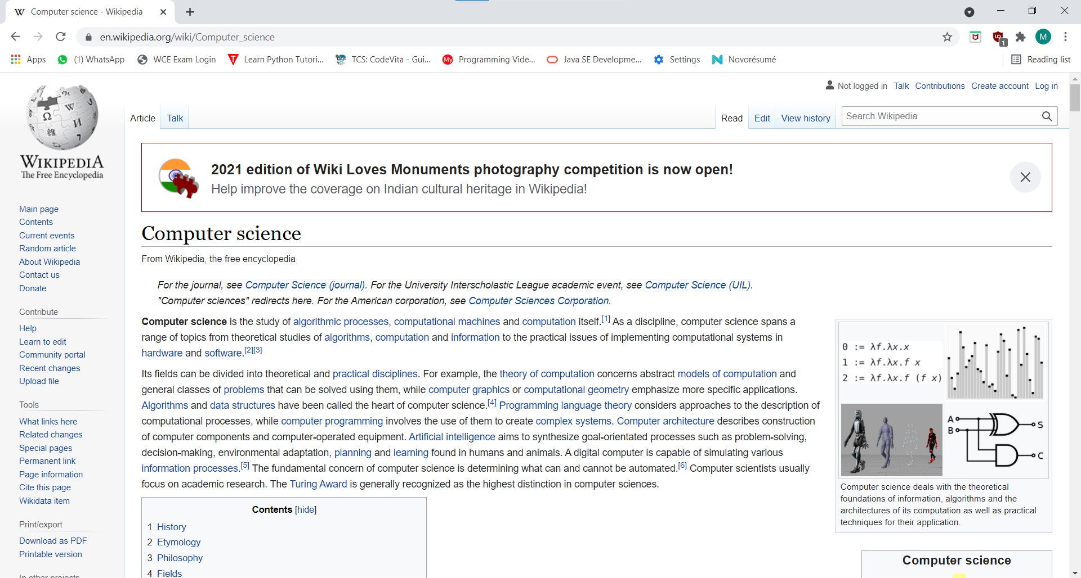

Website opened in Google Chrome

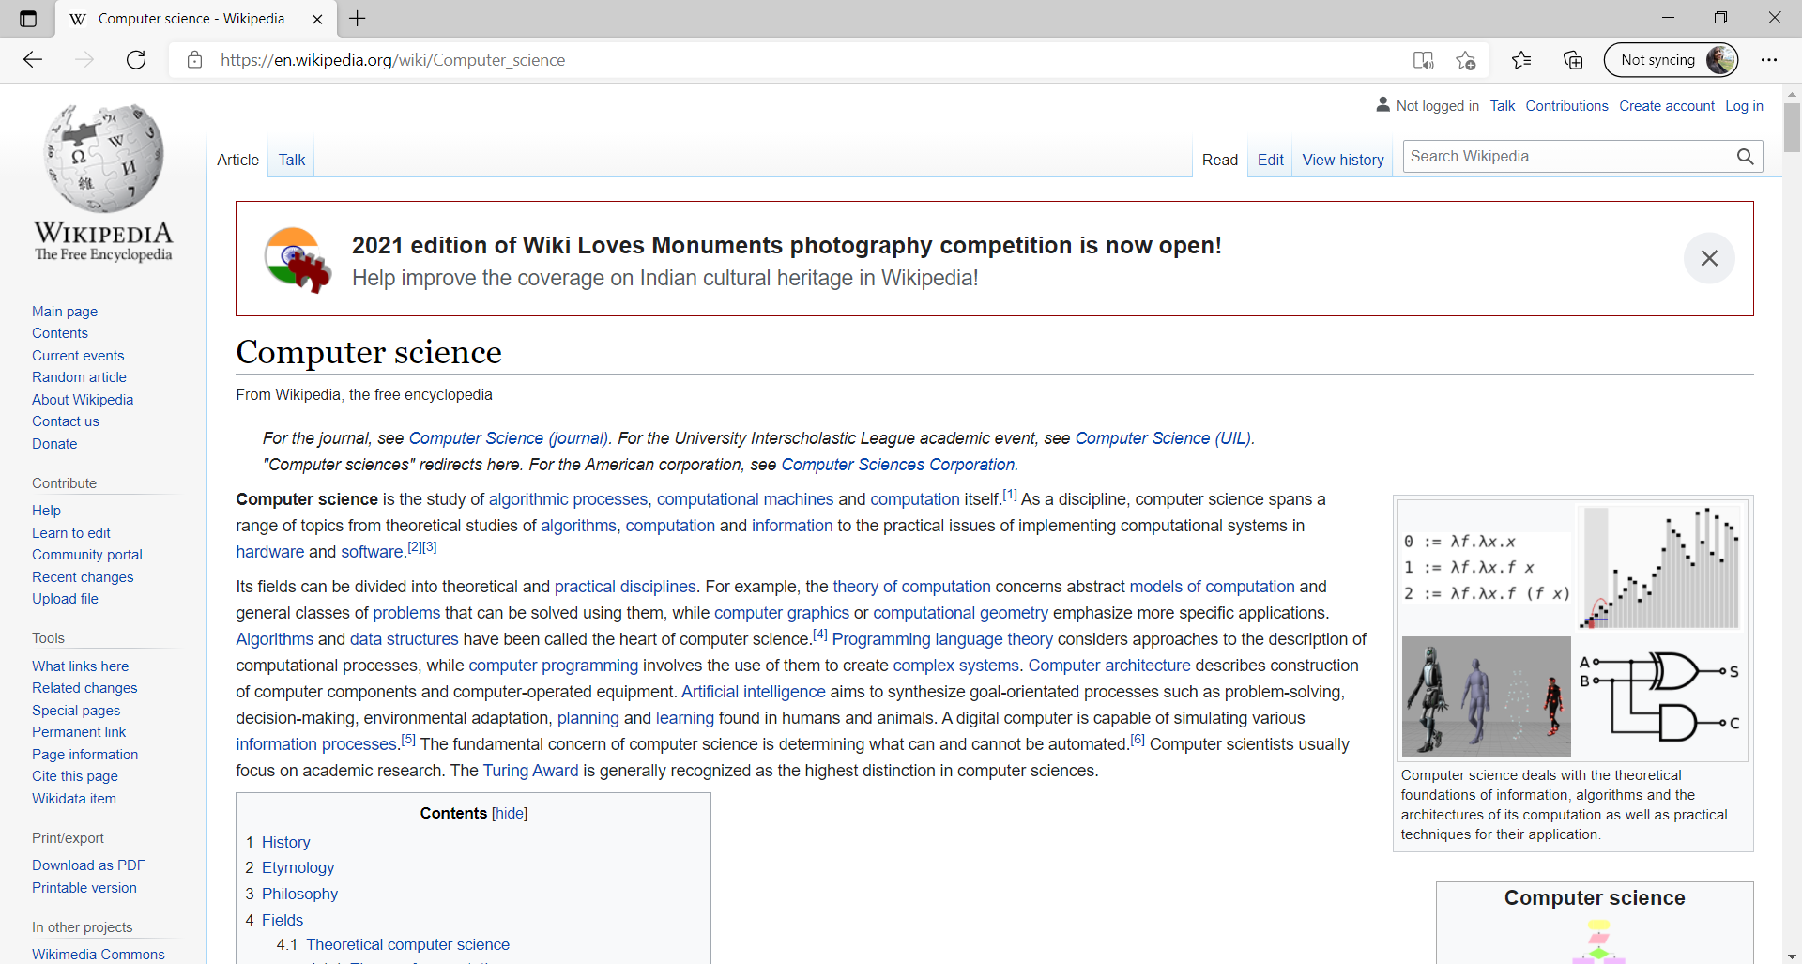

Website opened in Edge

1. Using browser’s Developer Tools option find out how many request-response cycles are needed to load the page fully on your machine?

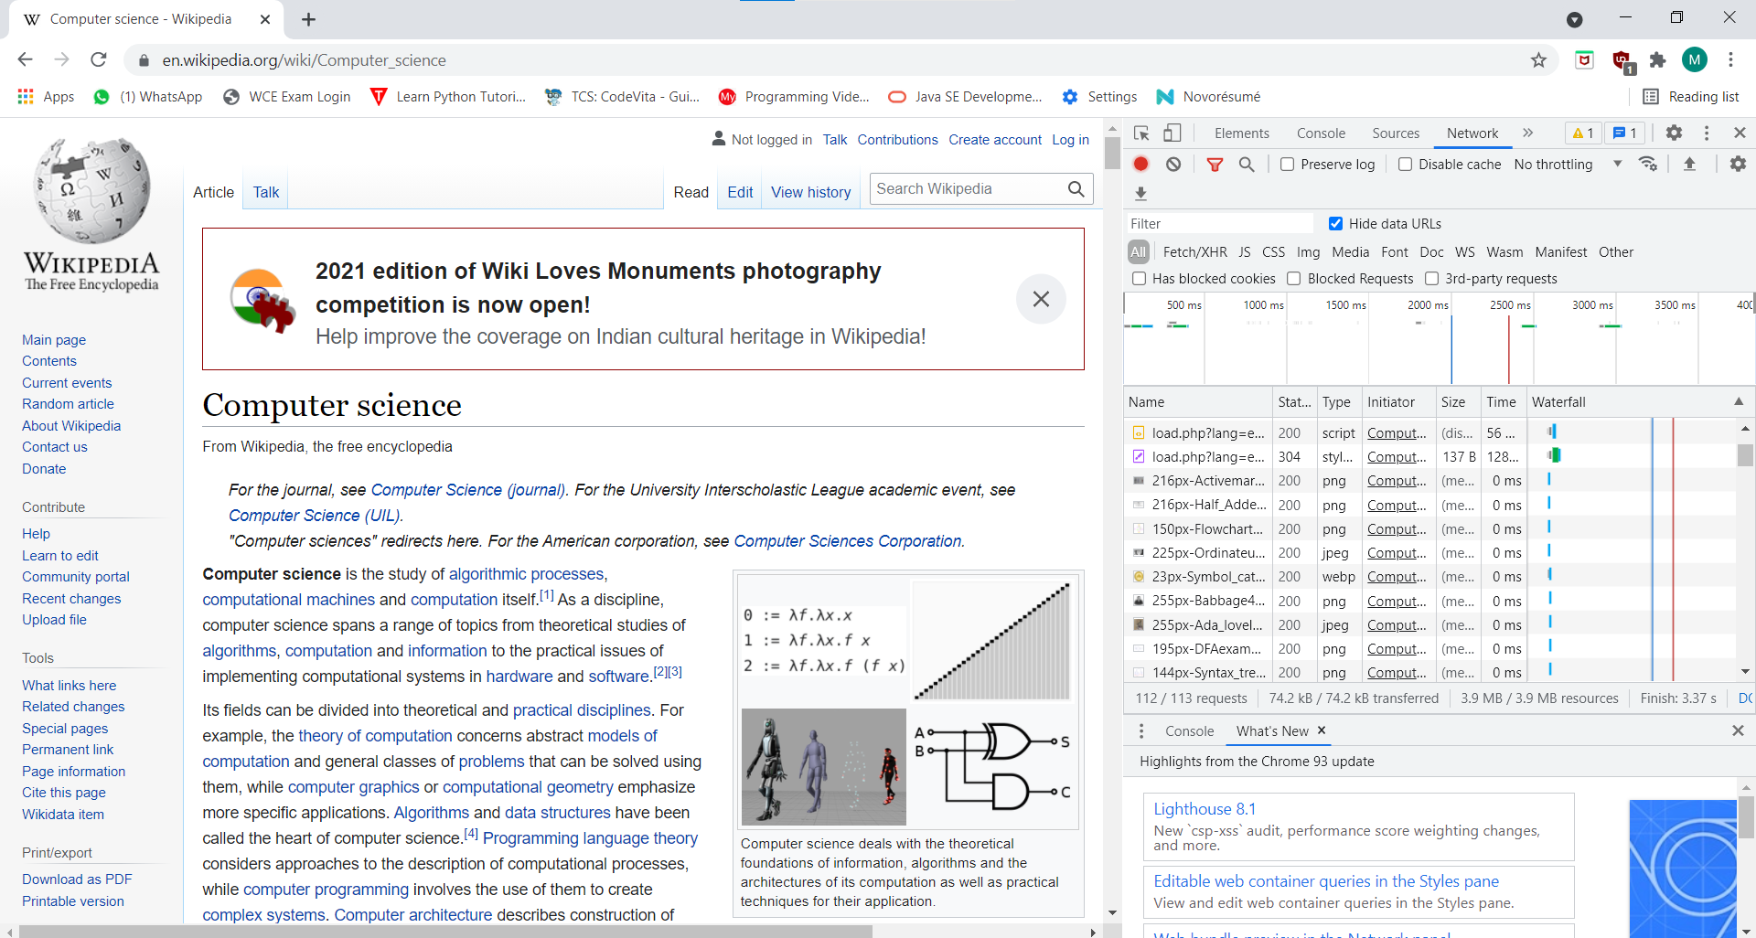

Total 112 request-response cycles are made in Google Chrome.

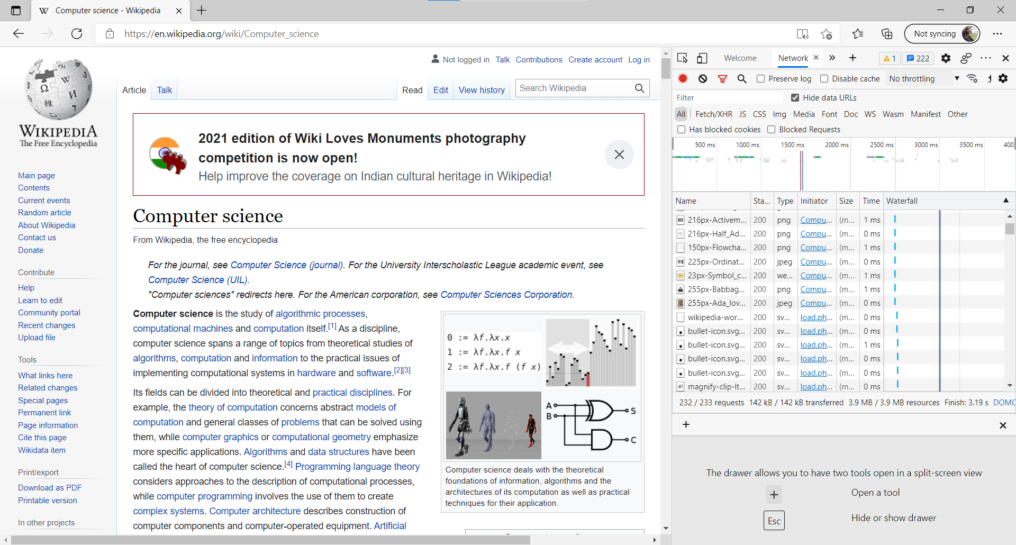Total 232 request-response cycles are made in Microsoft Edge

1. Using browser’s Developer Tools option get the header information of the page.

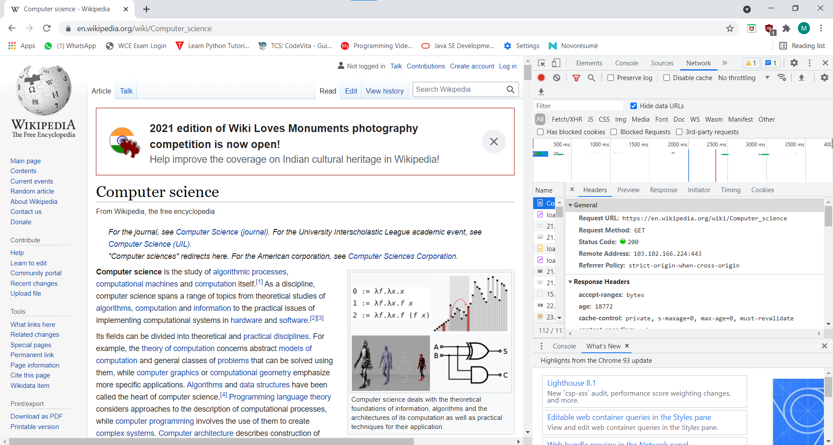

The header information of the page in Google Chrome

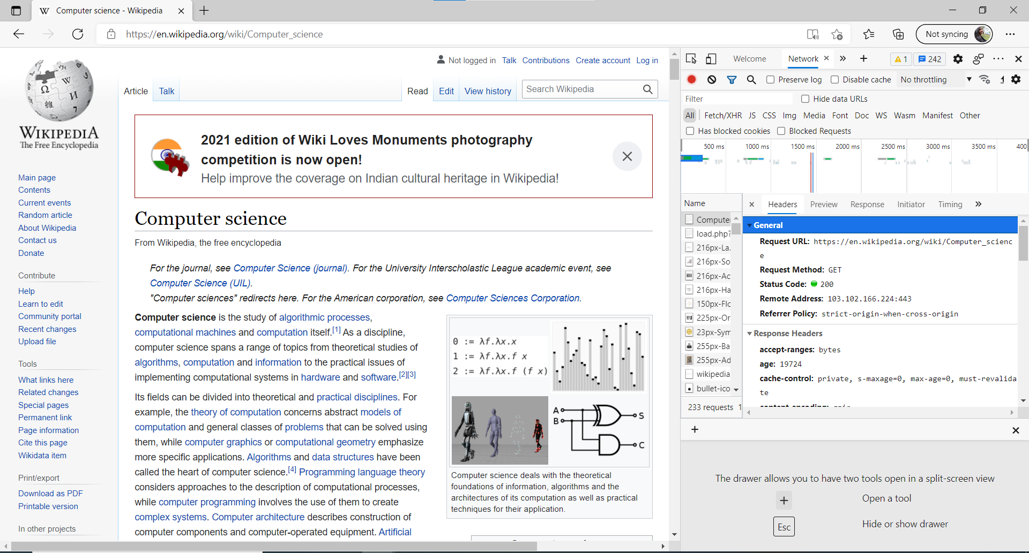

The header information of page in Microsoft Edge

1. Using browser’s Developer Tools option go through the DOM, CSS editor and JavaScript debugger options.

**DOM**

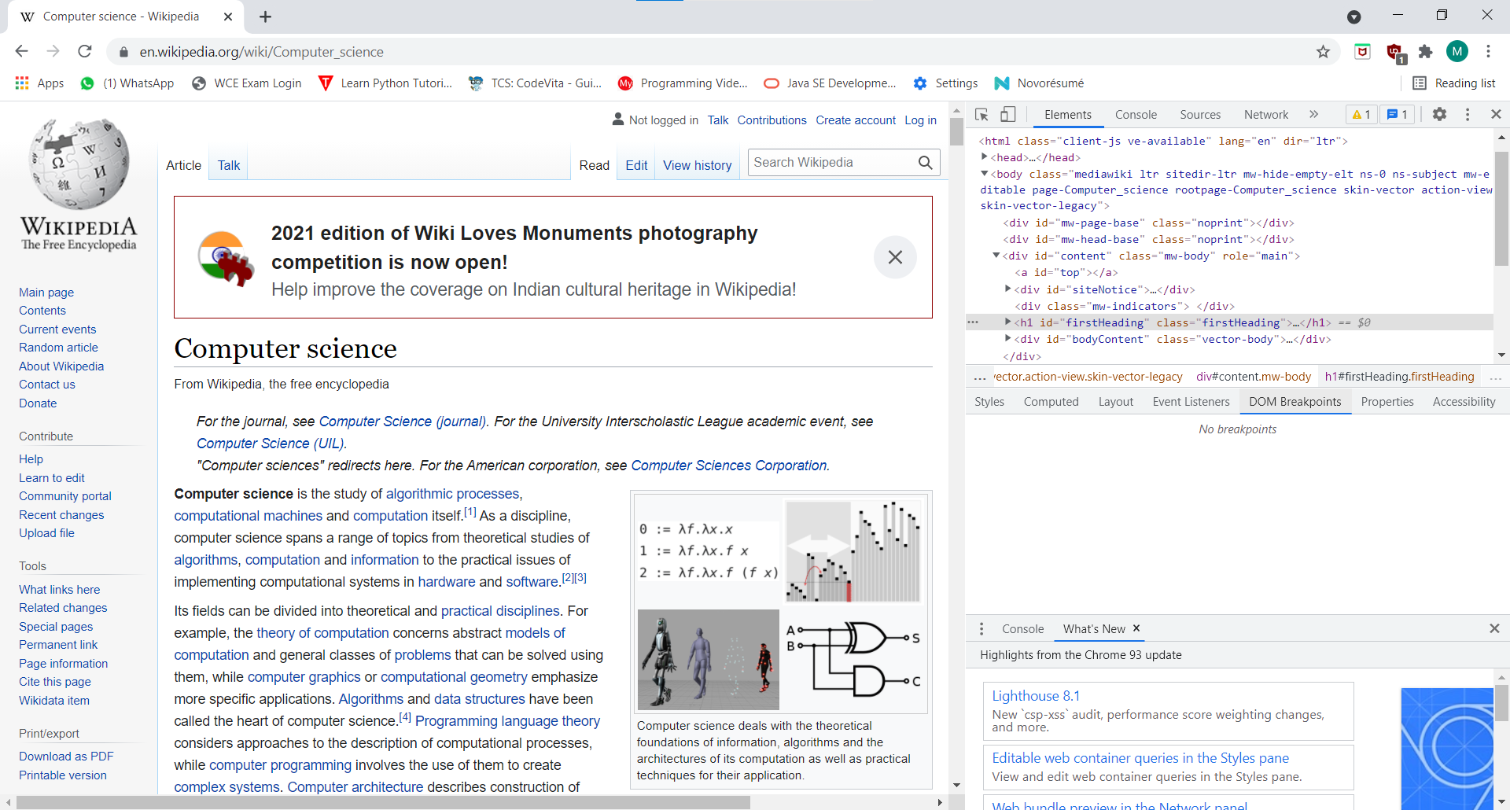

In Chrome

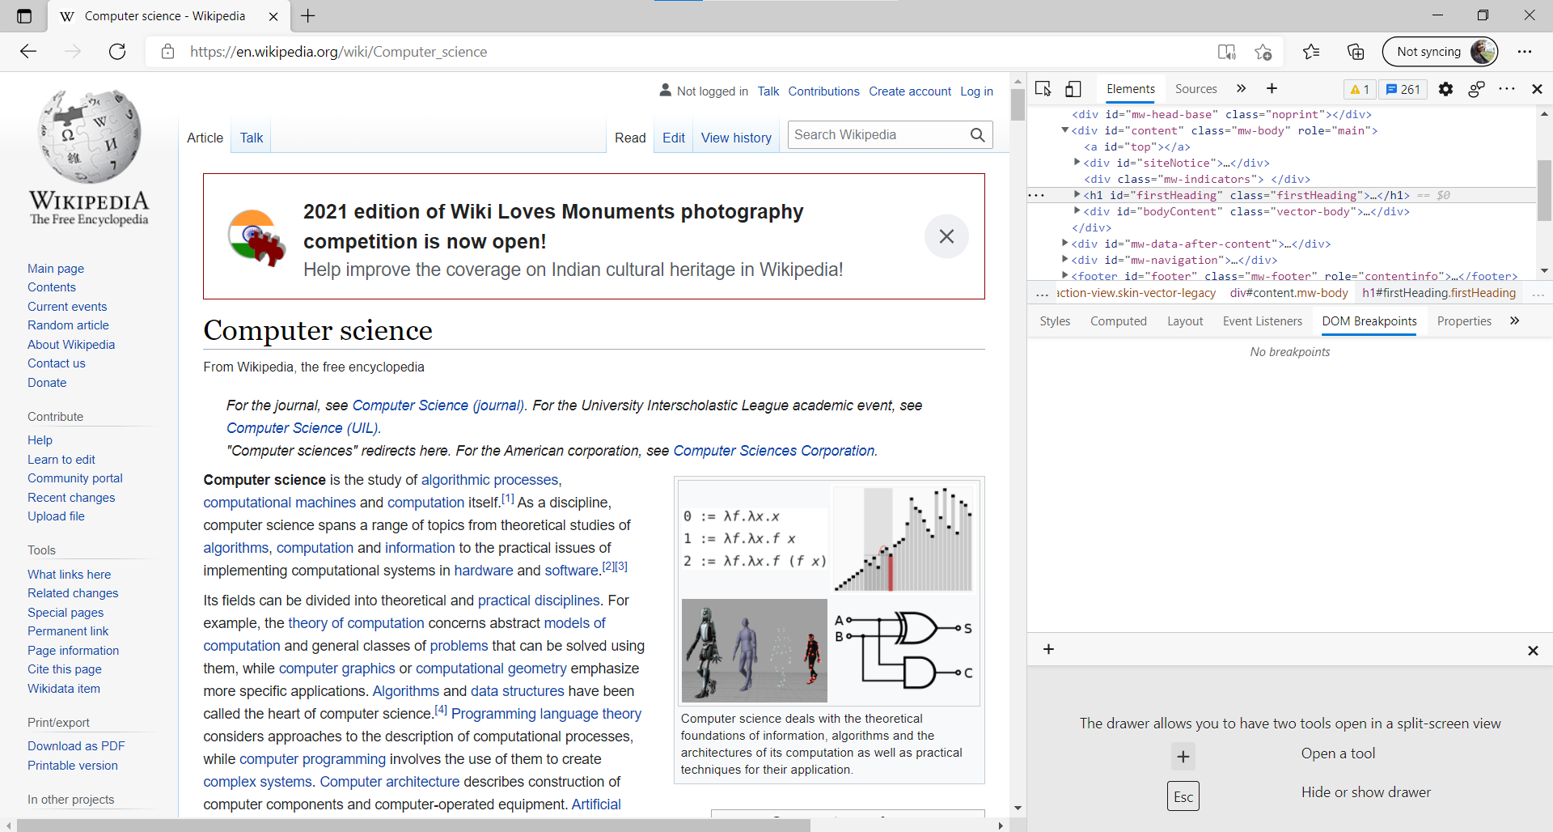

In Edge

**CSS Editor**

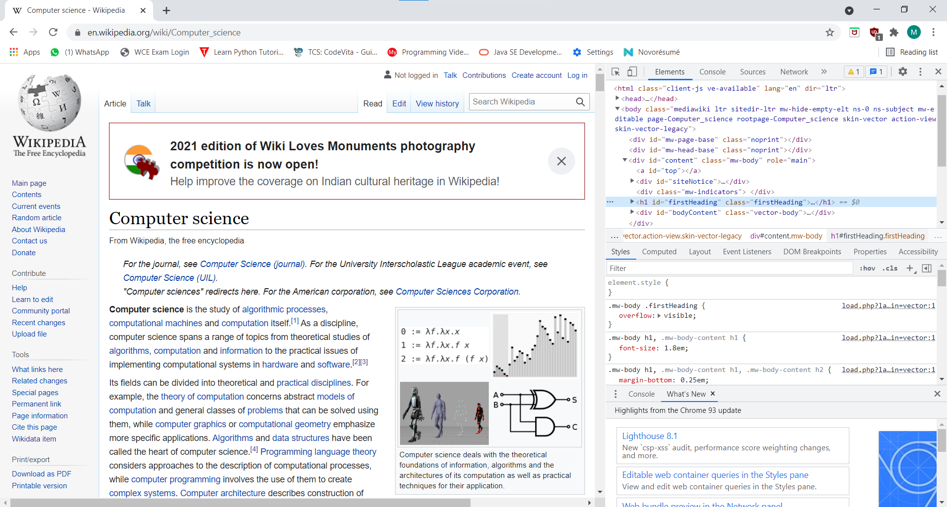

In Chrome

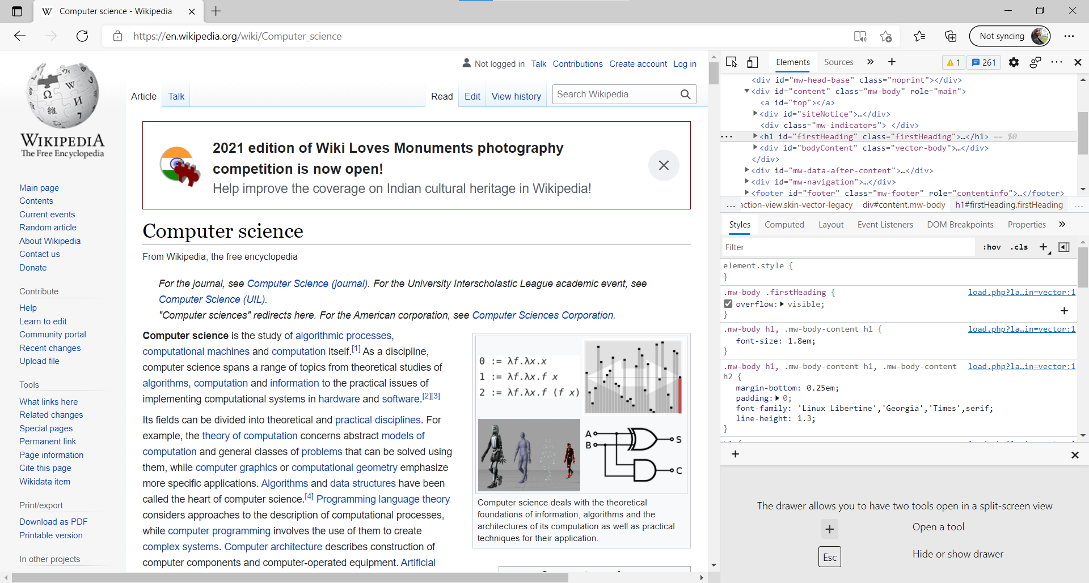

In Edge

**JavaScript Debugger Option:**

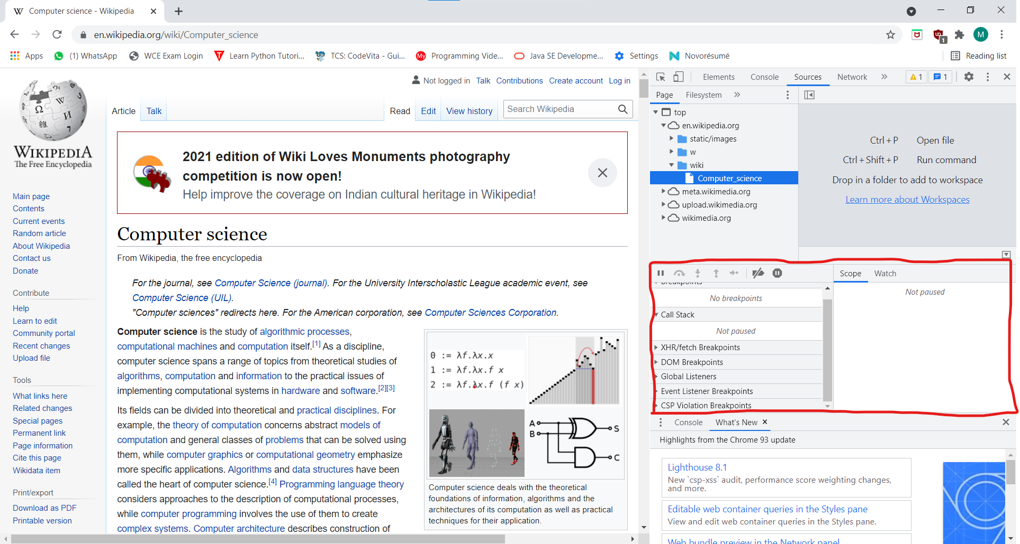

In Chrome

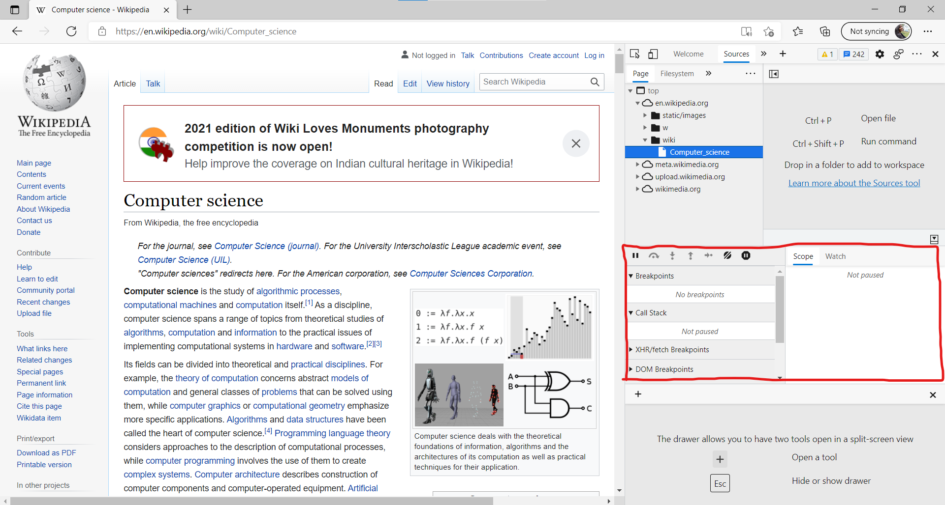

In Edge